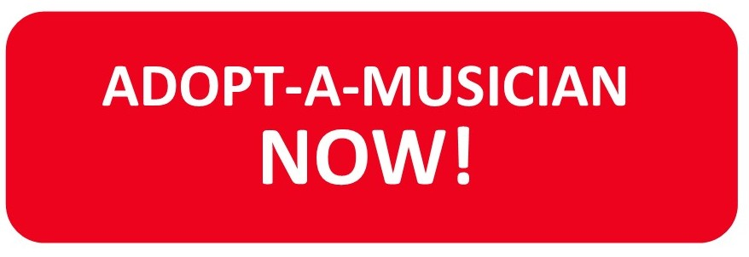

Your Name: _________________________________________________________

Address: _________________________________________________________

City & Zip: _________________________________________________________

Phone #: _________________________________________________________

Email: __________________________________________________________

I wish to adopt (please indicate):

Principal Player $500 Non-principal player $250

If you have a preference for a named musician from the attached list, please indicate it here.

Named player:

Form of Payment: Check: _____________ Credit Card: ___________

Check:
Name on check: _______________________________________________________

Check Number: ___________________

Credit Card:
Name on Card: ______________________________________________________

Credit card type: Visa: ________ Mastercard: ________Amex: ________

Card number: ________________________________________________________

Exp. Date: ________/____________ Security Code: ______________

Mail to: Laredo Philharmonic, P.O. Box 451644, Laredo TX 78045

